C.S.DAV PUBLIC SCHOOL
CLASS: 9th
Notes of Maths
Chapters: 01 & 02
Submitted By Mr. Pappu Singh

Chapter:- 1

Introduction to Natural Numbers
Non-negative counting numbers excluding zero are called Natural Numbers.
N = 1, 2, 3, 4, 5, ……….

Whole Numbers
All natural numbers including zero are called Whole Numbers.
W = 0, 1, 2, 3, 4, 5, …………….

Integers
All natural numbers, negative numbers and 0, together are called Integers.
Z = – 3, – 2, – 1, 0, 1, 2, 3, 4, …………..

Rational Numbers
The number ‘a’ is called Rational if it can be written in the form of r/s where ‘r’ and ‘s’ are integers and s ≠ 0,
Q = 2/3, 3/5, etc. all are rational numbers.

How to find a rational number between two given numbers?
To find the rational number between two given numbers ‘a’ and ‘b’.
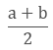
Example:
Find 2 rational numbers between 4 and 5.
Solution:
To find the rational number between 4 and 5
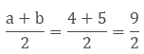
To find another number we will follow the same process again.
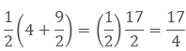
Hence the two rational numbers between 4 and 5 are 9/2 and 17/4.
Remark: There could be unlimited rational numbers between any two rational numbers.

Irrational Numbers
The number ‘a’ which cannot be written in the form of p/q is called irrational, where p and q are integers and q ≠ 0 or you can say that the numbers which are not rational are called Irrational Numbers.
Example - √7, √11 etc.

Real Numbers
All numbers including both rational and irrational numbers are called Real Numbers.
R = – 2, – (2/3), 0, 3 and √2
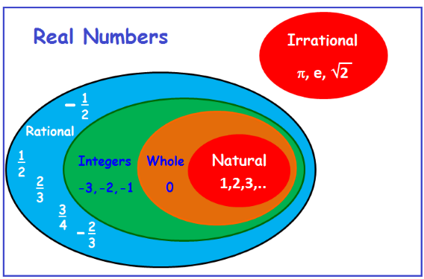

Real Numbers and their Decimal Expansions
1. Rational Numbers
If the rational number is in the form of a/b then by dividing a by b we can get two situations.
a. If the remainder becomes zero
While dividing if we get zero as the remainder after some steps then the decimal expansion of such number is called terminating.
Example:
7/8 = 0.875
b. If the remainder does not become zero
While dividing if the decimal expansion continues and not becomes zero then it is called non-terminating or repeating expansion.
Example:
1/3 = 0.3333….
Hence, the decimal expansion of rational numbers could be terminating or non-terminating recurring and vice-versa.
2. Irrational Numbers
If we do the decimal expansion of an irrational number then it would be non –terminating non-recurring and vice-versa. i. e. the remainder does not become zero and also not repeated.
Example:
π = 3.141592653589793238……

Representing Real Numbers on the Number Line
To represent the real numbers on the number line we use the process of successive magnification in which we visualize the numbers through a magnifying glass on the number line.
Example:
Step 1: The number lies between 4 and 5, so we divide it into 10 equal parts. Now for the first decimal place, we will mark the number between 4.2 and 4.3.
Step 2: Now we will divide it into 10 equal parts again. The second decimal place will be between 4.26 and 4.27.
Step 3: Now we will again divide it into 10 equal parts. The third decimal place will be between 4.262 and 4.263.
Step 4: By doing the same process again we will mark the point at 4.2626.
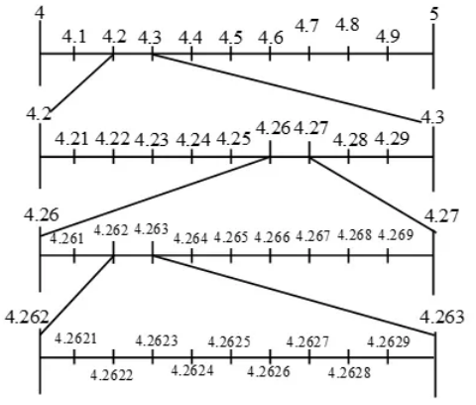

Operations on Real Numbers
1. The sum, difference, product and quotient of two rational numbers will be rational.
Example:
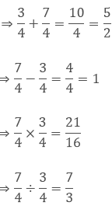
2. If we add or subtract a rational number with an irrational number then the outcome will be irrational.
Example:
If 5 is a rational number and √7 is an irrational number then 5 + √7 and 5 - √7 are irrational numbers.
3. If we multiply or divide a non-zero rational number with an irrational number then also the outcome will be irrational.
Example:
If 7 is a rational number and √5 is an irrational number then 7√7 and 7/√5 are irrational numbers.
4. The sum, difference, product and quotient of two irrational numbers could be rational or irrational.
Example:
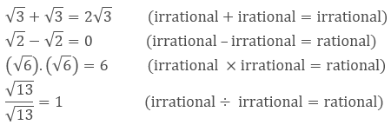

Finding Roots of a Positive Real Number ‘x’ geometrically and mark it on the Number Line
To find √x geometrically
1. First of all, mark the distance x unit from point A on the line so that AB = x unit.
2. From B mark a point C with the distance of 1 unit, so that BC = 1 unit.
3. Take the midpoint of AC and mark it as O. Then take OC as the radius and draw a semicircle.
4. From the point B draw a perpendicular BD which intersects the semicircle at point D.
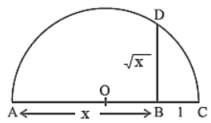
The length of BD = √x.
To mark the position of √x on the number line, we will take AC as the number line, with B as zero. So C is point 1 on the number line.
Now we will take B as the centre and BD as the radius, and draw the arc on the number line at point E.
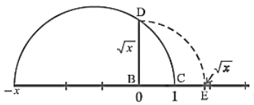
Now E is √x on the number line.

Identities Related to Square Roots
If p and q are two positive real numbers
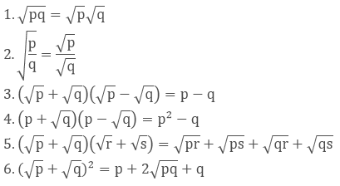
Examples:
1. Simplify
We will use the identity
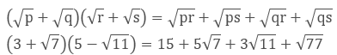
2. Simplify
We will use the identity
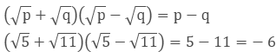

Rationalizing the Denominator
Rationalize the denominator means to convert the denominator containing square root term into a rational number by finding the equivalent fraction of the given fraction.
For which we can use the identities of the real numbers.
Example:
Rationalize the denominator of 7/(7- √3).
Solution:
We will use the identityhere.
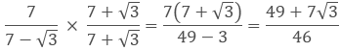

Laws of Exponents for Real Numbers
If we have a and b as the base and m and n as the exponents, then
1. a^{m} × a^{n} =a^{m+n}
2. (a^{m})^{n} = a^{mn}
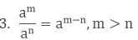
4. a^{m} b^{m} = (ab)^{m}
5. a⁰ = 1
6. a¹ = a
7. 1/a^{n} = a^{-n}
- Let a > 0 be a real number and n a positive integer.
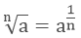
- Let a > 0 be a real number. Let m and n be integers such that m and n have no common factors other than 1, and n > 0. Then,
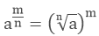
Example:
Simplify the expression (2x³y⁴) (3xy⁵)².
Solution:
Here we will use the law of exponents
a^{m} × a^{n} =a^{m+n} and (a^{m})^{n} = a^{mn}
(2x³y⁴)(3xy⁵)²
(2x³y⁴)(3 ² x ² y¹⁰)
18. x³. x². y⁴. y¹⁰
18. x³⁺². y⁴⁺¹⁰
18x⁵y¹⁴

CHAPTER:- 2

Polynomial
Polynomial is an algebraic expression which includes constants, variables and exponents. It is the expression in which the variables have only positive integral powers.

Example
1. 4x³ + 3x² + x +3 is a polynomial in variable x.
2. 4x² + 3x⁻¹ - 4 is not a polynomial as it has negative power.
3. 3x^{3/2} + 2x – 3 is not a polynomial.
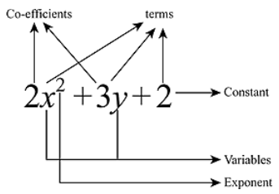
- Polynomials are denoted by p(x), q(x) etc.
- In the above polynomial 2x², 3y and 2 are the terms of the polynomial.
- 2 and 3 are the coefficient of the x² and y respectively.
- x and y are the variables.
- 2 is the constant term which has no variable.

Polynomials in One Variable
If there is only one variable in the expression then this is called the polynomial in one variable.

Example
- x³ + x – 4 is polynomial in variable x and is denoted by p(x).
- r² + 2 is polynomial in variable r and is denoted by p(r).
Types of polynomials on the basis of the number of terms
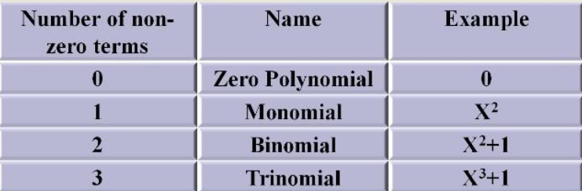
Types of polynomials on the basis of the number of degrees
The highest value of the power of the variable in the polynomial is the degree of the polynomial.

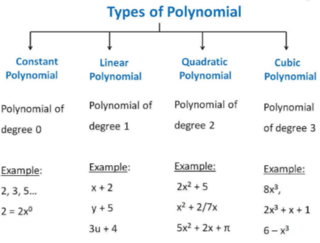

Zeroes of a Polynomial
If p(x) is a polynomial then the number ‘a’ will be the zero of the polynomial with p(a) = 0. We can find the zero of the polynomial by equating it to zero.

Example: 1
Given polynomial is p(x) = x - 4
To find the zero of the polynomial we will equate it to zero.
x - 4 = 0
x = 4
p(4) = x – 4 = 4 – 4 = 0
This shows that if we place 4 in place of x, we got the value of the polynomial as zero. So 4 is the zero of this polynomial. And also we are getting the value 4 by equating the polynomial by 0.
So 4 is the zero of the polynomial or root of the polynomial.
The root of the polynomial is basically the x-intercept of the polynomial.
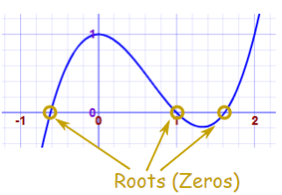
If the polynomial has one root, it will intersect the x-axis at one point only and if it has two roots then it will intersect at two points and so on.

Example: 2
Find p (1) for the polynomial p (t) = t² – t + 1
p (1) = (1)² – 1 + 1
= 1 – 1 + 1
= 1

Remainder Theorem
We know the property of division which follows in the basic division, i.e.
Dividend = (Divisor × Quotient) + Remainder
This same follows the division of polynomial.
If p(x) and g(x) are two polynomials in which the degree of p(x) ≥ degree of g(x) and g(x) ≠ 0 are given then we can get the q(x) and r(x) so that:
P(x) = g(x) q(x) + r(x),
where r(x) = 0 or degree of r(x) < degree of g(x).
It says that p(x) divided by g(x), gives q(x) as quotient and r(x) as remainder.
Let’s understand it with an example

Division of a Polynomial with a Monomial
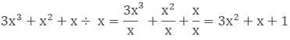
We can see that ‘x’ is common in the above polynomial, so we can write it as
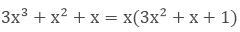
Hence 3x² + x + 1 and x the factors of 3x³ + x² + x.

Steps of the Division of a Polynomial with a Non –Zero Polynomial
Divide x² - 3x -10 by 2 + x
Step 1: Write the dividend and divisor in the descending order i.e. in the standard form. x² - 3x -10 and x + 2
Divide the first term of the dividend with the first term of the divisor.
x²/x = x this will be the first term of the quotient.
Step 2: Now multiply the divisor with this term of the quotient and subtract it from the dividend.
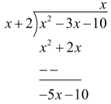
Step 3: Now the remainder is our new dividend so we will repeat the process again by dividing the dividend with the divisor.
Step 4: – (5x/x) = – 5
Step 5:
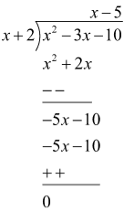
The remainder is zero.
Hence x² - 3x – 10 = (x + 2)(x - 5) + 0
Dividend = (Divisor × Quotient) + Remainder
Remainder Theorem says that if p(x) is any polynomial of degree greater than or equal to one and let ‘t’ be any real number and p (x) is divided by the linear polynomial x – t, then the remainder is p(t).
As we know that
P(x) = g(x) q(x) + r(x)
If p(x) is divided by (x-t) then
If x = t
P (t) = (t - t).q (t) + r = 0
To find the remainder or to check the multiple of the polynomial we can use the remainder theorem.

Example:
What is the remainder if a⁴ + a³ – 2a² + a + 1 is divided by a – 1.

Solution:
P(x) = a⁴ + a³ – 2a² + a + 1
To find the zero of the (a – 1) we need to equate it to zero.
a -1 = 0
a = 1
p (1) = (1)⁴ + (1)³ – 2(1)² + (1) + 1
= 1 + 1 – 2 + 1 + 1
= 2
So by using the remainder theorem, we can easily find the remainder after the division of polynomial.

Factor Theorem
Factor theorem says that if p(y) is a polynomial with degree n≥1 and t is a real number, then
- (y - t) is a factor of p(y), if p(t) = 0, and
- P (t) = 0 if (y – t) is a factor of p(y).

Example: 1
Check whether g(x) = x – 3 is the factor of p(x) = x³ - 4x² + x + 6 using factor theorem.

Solution:
According to the factor theorem if x - 3 is the factor of p(x) then p(3) = 0, as the root of x – 3 is 3.
P (3) = (3)³ - 4(3)² + (3) + 6
= 27 – 36 + 3 + 6 = 0
Hence, g(x) is the factor of p(x).

Example: 2
Find the value of k, if x – 1 is a factor of p(x) = kx² – √2x + 1

Solution:
As x -1 is the factor so p(1) = 0
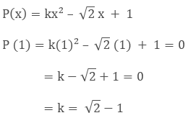

Factorization of Polynomials
Factorization can be done by three methods
1. By taking out the common factor
If we have to factorize x² –x then we can do it by taking x common.
x(x – 1) so that x and x-1 are the factors of x² – x.
2. By grouping
ab + bc + ax + cx = (ab + bc) + (ax + cx)
= b(a + c) + x(a + c)
= (a + c)(b + x)
3. By splitting the middle term
x² + bx + c = x² + (p + q) + pq
= (x + p)(x + q)
This shows that we have to split the middle term in such a way that the sum of the two terms is equal to ‘b’ and the product is equal to ‘c’.

Example: 1
Factorize 6x² + 17x + 5 by splitting the middle term.

Solution:
If we can find two numbers p and q such that p + q = 17 and pq = 6 × 5 = 30, then we can get the factors.
Some of the factors of 30 are 1 and 30, 2 and 15, 3 and 10, 5 and 6, out of which 2 and 15 is the pair which gives p + q = 17.
6x² + 17x + 5 =6 x² + (2 + 15) x + 5
= 6 x² + 2x + 15x + 5
= 2 x (3x + 1) + 5(3x + 1)
= (3x + 1) (2x + 5)
Algebraic Identities
1. (x + y)² = x² + 2xy + y²
2. (x - y)² = x² - 2xy + y²
3. (x + y) (x - y) = x² - y²
4. (x + a) (x + b) = x² + (a + b)x + ab
5. (x + y + z)² = x² + y² + z² + 2xy + 2yz + 2zx
6. (x + y)³ = x³ + y³ + 3xy(x + y) = x³+ y³ + 3x²y + 3xy²
7. (x - y)³ = x³- y³ - 3xy(x - y) = x³ - y³ - 3x²y + 3xy²
8. x³ + y³ = (x + y)(x² – xy + y²)
9. x³ - y³ = (x - y)(x² + xy + y²)
10. x³ + y³ + z³ - 3xyz = (x + y + z)(x² + y² + z² – xy – yz - zx)
x³ + y³ + z³ = 3xyz if x + y + z = 0

Example: 2
Factorize 8x³ + 27y³ + 36x²y + 54xy²

Solution:
The given expression can be written as
= (2x)³ + (3y)³ + 3(4x²) (3y) + 3(2x) (9y²)
= (2x)³ + (3y)³ + 3(2x)²(3y) + 3(2x)(3y)²
= (2x + 3y)³ (Using Identity VI)
= (2x + 3y) (2x + 3y) (2x + 3y) are the factors.

Example: 3
Factorize 4x² + y² + z² – 4xy – 2yz + 4xz.

Solution:
4x² + y² + z² – 4xy – 2yz + 4xz = (2x)² + (–y)² + (z)² + 2(2x) (-y)+ 2(–y)(z) + 2(2x)(z)
= [2x + (- y) + z]² (Using Identity V)
= (2x – y + z)² = (2x – y + z) (2x – y + z)

……….COMPLETED……….

